Done by:

IT_AIML_B05

18481A1271 M.Soumya

18481A1276 N.Nikhila

18481A12A3 Triveni

18481A12B1 Sri Valli

Dynamic Price Prediction for Travel

Using IBM Watson

Dynamic Pricing Prediction for

Travel

**Introduction:**

Many organizations do not have a direct role in travel and tourism but offer related products and services. Some examples would be offering travel insurance, parking facilities at airports, theatre and event tickets, car hire, and travel by rail or coach to airports, etc. at competitive rates. There are various different forms of dynamic pricing. They are:

**Dynamic Pricing:**

In essence, dynamic pricing is the concept of pricing the product based on the changing dynamics of the current market demand. This is why it is also called Real-Time Pricing, Surge Pricing or time-based Pricing.The Decision Making Process Behind the dynamic pricing model is quite impressive. Under the Artificial Intelligence, Machine Learningrobots are working for you to develop new algorithmic models based on the market demands and your competitors actions. This data driven process allows companies to adjust the prices of their products continuously within seconds.

Dynamic Pricing Strategy is popular among many business models. But the first Companies that spring to mind are the airline Industry, ecommerce businesses, public transportation, retail and environment. Since each of these Industries has different Mechanics they use different types of dynamic pricing models.

There are various different forms of dynamic pricing:  
1. Peak Pricing – This is a strategy that is common in transportation businesses. Airlines are a good example. Airlines often charge a higher price to travel during rush hour mostly on weekdays and sometimes on weekends.  
2. Surge Pricing – Companies such as Uber respond dynamically to changes in supply and demand in order to price their services differently. Like most of us have noticed, this frequently happens on stormy evenings and nights when more people request for cabs. Taxify also not so long ago introduced dynamic pricing to ensure the drivers are encouraged to go online and offer services when the demand is high.

**Solution Requirement:**

Every day the price of travel was changed due to the demand for public uses. The framework developed for the price prediction is analyzed for the travel plans. For the same travel plan offered at a fixed price for a particular group of customers, our proposed model saw a final fare with a lesser number of errors in predicting customer planning. As time progresses and more data are collected, the supervised learning will produce more accurate results and will be helpful in determining fare optimizer and dynamic availability of adjustments and continuously improve future recommendations.

**Technical Architecture:**

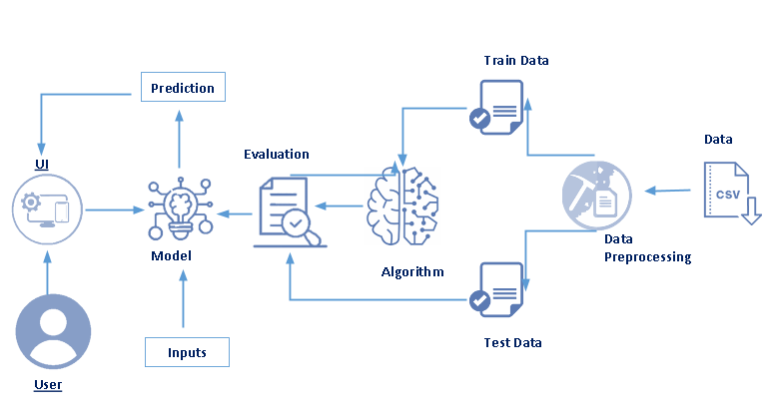

**Pre-Requisites**

In order to develop this Project we need to install following software/packages:

**Anaconda Navigator :**

Anaconda Navigator is a free and open-source distribution of the Python and R programming languages for data science and machine learning related applications. It can be installed on Windows, Linux, and macOS.Conda is an open-source, cross-platform,  package management system. Anaconda comes with so very nice tools like JupyterLab, Jupyter Notebook,

QtConsole, Spyder, Glueviz, Orange, Rstudio, Visual Studio Code. For this project, we will be using Jupyter notebook and Spyder

To install Anaconda navigator and to know how to use Jupyter Notebook & Spyder using Anaconda watch the video.

Link:<https://youtu.be/5mDYijMfSzs>

To make a responsive python script you must require the following packages

**Requests:** Allows you to send HTTP requests using Python.

**Flask:** Web framework used for building Web applications.

Link: <https://youtu.be/akj3_wTploU>

If you are using anaconda navigator, follow below steps to download required packages:

* Open the anaconda prompt.
* Type "pip install requests” and click enter.
* Type “pip install Flask” and click enter.

If you are using Pycharm IDE, you can install the packages through the command prompt and follow the same syntax as above.

**Prior Knowledge :** One should have knowledge on the following Concepts:

**Requests:**Allows you to send HTTP requests using Python.

**Flask:** Web framework used for building Web applications.

Link: <https://youtu.be/lj4I_CvBnt0>

**Project Objectives:**

Write what are all the technical aspects that students would get if they complete this project.

1. Knowledge on Machine Learning Algorithms.
2. Knowledge on Python Language with Machine Learning
3. Knowledge on Statistics and Graphs and their relations
4. You’ll be able to understand the problem to classify if it is a regression or a classification kind of problem.
5. You will be able to know how to pre-process / clean the data using different data pre-processing techniques.
6. Applying different algorithms according to the dataset and based on visualization.
7. Real Time Analysis of Project
8. Building an ease of User Interface (UI)
9. Navigation of ideas towards other projects(creativeness)
10. Knowledge on building ML Model..
11. You will be able to know how to find the accuracy of the model.
12. How to Build web applications using the Flask framework.

**Project Flow**

1. Install Required Libraries.
2. Data Collection.

* Collect the dataset or Create the dataset

1. Data Pre- processing.

* Import the Libraries.
* Importing the dataset.
* Understanding Data Type and Summary of features.
* Take care of missing data & create columns.
* Data Visualization.
* Drop the column from dataframe, merge the dataframes.
* Observing Target,Numerical and Categorical Columns
* Label Encoding & Splitting the Dataset into Dependent and Independent variables
* Splitting Data into Train and Test.

1. Model Building

* Training and testing the model

Evaluation of Model

* Saving the Model

1. Application Building

* Create an HTML file
* Build a Python Code

1. Final UI

* Dashboard Of the flask app.

**Project Structure**

Create a Project folder which contains files as shown below.

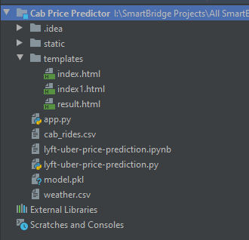

* We are building a Flask Application which needs HTML pages “**index.html**” ,“**index1.html**” ,“**result.html**” stored in the templates folder and a python script **app.py**  for server side scripting
* The model is built in the notebook **lyft-uber-price-prediction.ipynb**
* We need the model which is saved and the saved model in this content is **model.pkl.**
* The static folder will contain a css file which is  used in the html file.
* The templates mainly used here are “**index.html**”,”**index1.html**”, “**result.html**” for showcasing the UI
* The flask app is denoted as **app.py**

**Install Required Packages**

* To complete the project, you need the following packages and libraries.

1. Anaconda Navigator
2. Jupyter
3. Numpy
4. Pandas
5. Matplotlib
6. Scikit-Learn

Install Anaconda software

To install Anaconda on your local system, go through the below links according to your system requirements. After Anaconda is installed, run the .exe folder.

**For Windows-** [Link](https://problemsolvingwithpython.com/01-Orientation/01.03-Installing-Anaconda-on-Windows/)  
**For MacOS-**[Link](https://problemsolvingwithpython.com/01-Orientation/01.04-Installing-Anaconda-on-MacOS/) **For Linux-**[Link](https://docs.anaconda.com/anaconda/install/linux/)

Install Required Libraries

Search Anaconda Navigator and open a Jupyter notebook

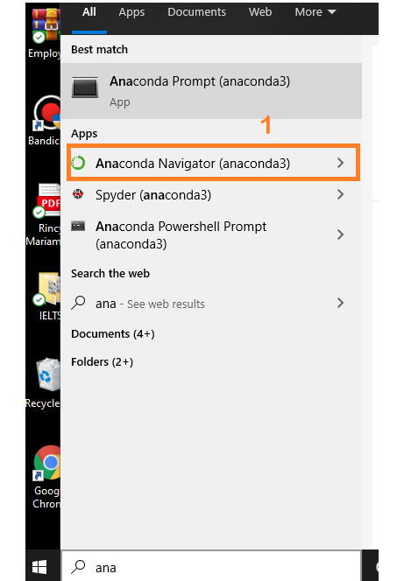

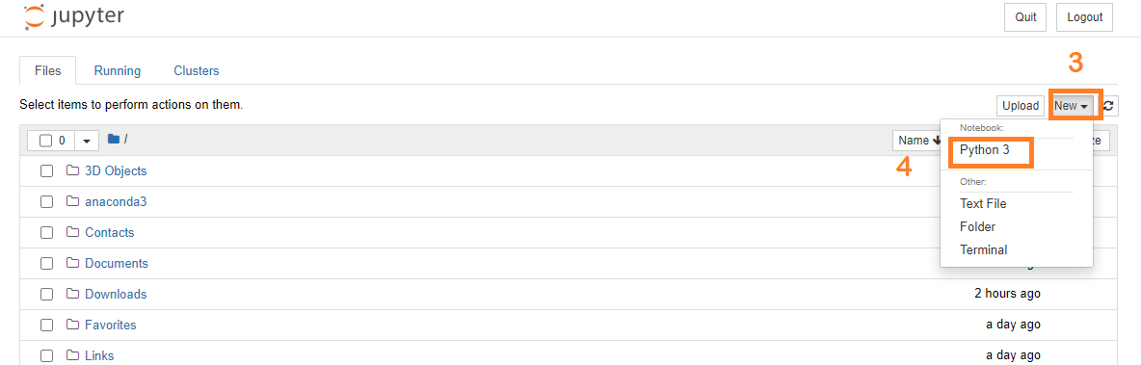

**Installation of NumpyLibrary :**

**Using Anaconda Navigator**: conda install numpy  
**OR**  
**Using command prompt**: pip install numpy.

**Installation of Pandas Library :**

**Using Anaconda Navigator:** conda install pandas

**OR**

**Using command prompt:** pip install pandas.

**Installation of Matplotlib Library :**

**Using Anaconda Navigator:** conda install matplotlib

**OR**

**Using command prompt:** pip install matplotlib

**Installation of Scikit-Learn Library :**

**Using Anaconda Navigator:** conda install -c conda-forge scikit-learn

**OR**

**Using command prompt:** pip install -U scikit-learn

**Dataset Collection**

**Collect The Dataset Or Create The Dataset**

* ML depends heavily on data, without data, it is impossible for an “AI” to learn. It is the most crucial aspect that makes algorithm training possible. In Machine Learning projects, we need a training data set. It is the actual data set used to train the model for performing various actions.
* There are many features which are responsible for Dynamic price prediction for travel, e.g. Cab type,CabName,Source ,Destination, Cab service type etc. For better prediction of the Dynamic price for travel, we should consider as many relevant features as possible.
* You can collect dataset from different open sources like kaggle.com, data.gov, UCI machine learning repository etc.
* Here we are using a data set which you can find in the below link and you can download it from the link



Link: https://drive.google.com/drive/folders/1aps_EnFDd_cwotPYkLQu7a1DqpTdUu1

**Data Pre-Processing**

**Import The Libraries**

Import the required libraries for the model to run.

First step is usually importing the libraries that will be needed in the program.

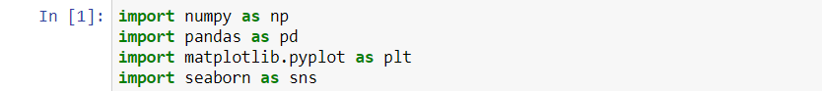

**Numpy**- It is an open-source numerical Python library. It contains a multi-dimensional array and matrix data structures. It can be used to perform mathematical operations on arrays such as trigonometric, statistical, and algebraic routines. Pandas objects are very much dependent on NumPy objects.

**Pandas**- It is a fast, powerful, flexible and easy to use open source data analysis and manipulation tool, built on top of the Python programming language.

**Counter**: Python Counter is a container that will hold the count of each of the elements present in the container.

**Matplotlib and Seaborn**: Both are the data visualization library used for plotting graphs which will help us to understand the data.

**Accuracy score**: used in classification type problems and for finding accuracy.

**Train_test_split**: used for splitting data arrays into training data and for testing data.

**Pickle**: to serialize your machine learning algorithms and save the serialized format to a file.

**Random Forest Regressor**: random forest is a meta estimator that fits a number of classifying decision trees on various sub-samples of the dataset and uses averaging to improve the predictive accuracy and control over-fitting. The sub-sample size is controlled with the max_samples parameter if bootstrap=True (default), otherwise the whole dataset is used to build each tree.

**Label Encoding:** It is a popular encoding technique for handling categorical variables. In this technique, each label is assigned a unique integer based on alphabetical ordering.

**Reading The Dataset**

* Here, we are reading the dataset(.csv) from the system using pandas and storing it in a variable ‘df’. It's time to begin building your text classifier! The data has been loaded into a DataFrame called df. The .head() method is particularly informative.
* You might have your data in .csv files,.excel files or .tsv files or something else. But the goal is the same in all cases. If you want to analyse that data using pandas, the first step will be to read it into a data structure that’s compatible with pandas.
* Let’s load a .csv data file into pandas. There is a function for it, called read_csv().We will need to locate the directory of the CSV file at first (it’s more efficient to keep the dataset in the same directory as your program).
* There are two dataset one is representing the data of Cab Rides and another one is representing for weather data.

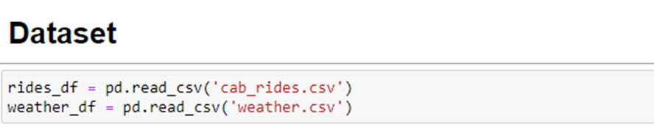

* If the dataset is in the same directory of your program, you can directly read it.
* To check the top five records of the dataset,simply write the dataframe name.head().
* Rides_df represent the data for the cab rides like type of cab,location,name etc.

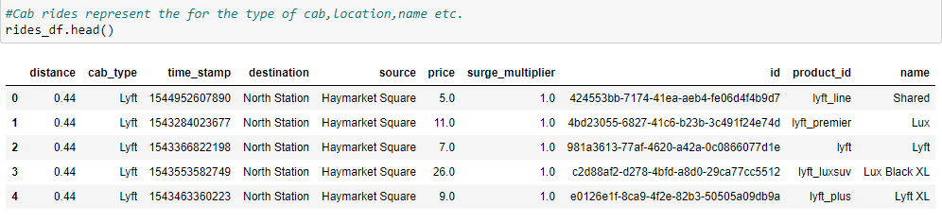

* Weather_df represents data for the weather like temperature, humidity etc

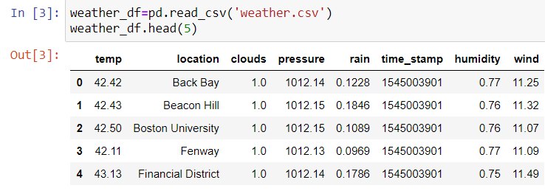

**Understanding Data Type and Summary of Features**

* How the information is stored in a DataFrame or Python object affects what we can do with it and the outputs of calculations as well. There are two main types of data: numeric and text data types.
* Numeric data types include integers and floats.
* Text data type is known as Strings in Python, or Objects in Pandas. Strings can contain numbers and / or characters.
* For example, a string might be a word, a sentence, or several sentences.
* Will see how our dataset is, by using info() method.
* info() method provides the summary of dataset.

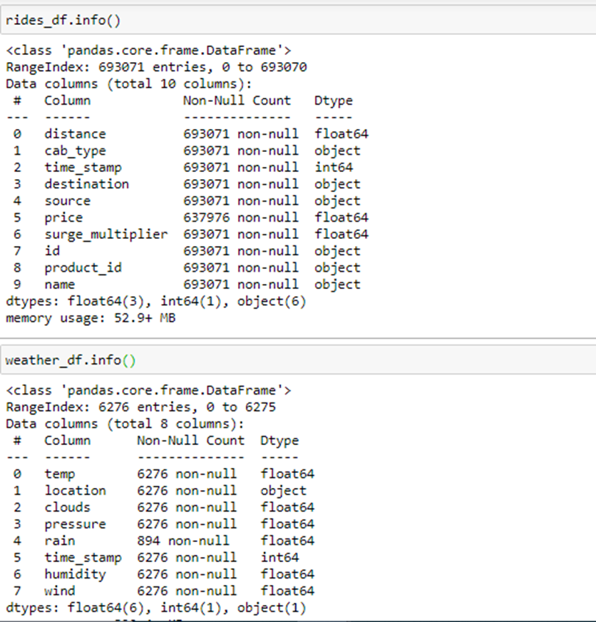

* As you can see in our dataset both numerical and categorical data are present, but it is not necessary that all the continuous data which we are seeing has to be continuous in nature. There may be a case that some categorical data is in the form of numbers but when we perform info() operation we will get numerical output. So, we need to take care of those types of data also.

### **Take Care of Missing Data & Create Columns**

* Sometimes you may find some data missing in the dataset. We need to be equipped to handle the problem when we come across them, obviously you could remove the entire line of data but what if you are unknowingly removing crucial information? of course we would not want to do that. One of the most common ideas to handle the problem is to take a mean of all the values for continuous and for categorical we make use of mode values and replace the missing data.
* Word “True” that the particular column has missing values, we can also see the count of missing values in each column by using isna().sum function.

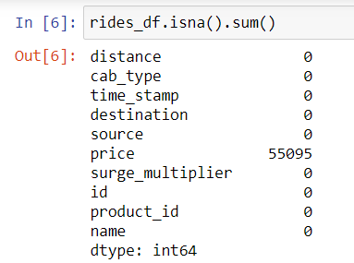

The fillna() function is used to fill NA/NaN values using the specified method.

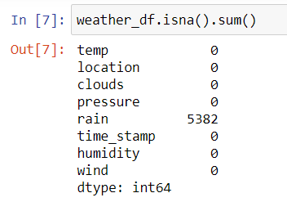



* Converting the timestamp data into real date format &creating the new column that contain the location and source.
* Using the datetime method to convert the time stamp into real date format





* The rides and weather data have been joined by merged_date column.
* Join the weather date on rides data
* 
* Check the Joined data info with the info() method

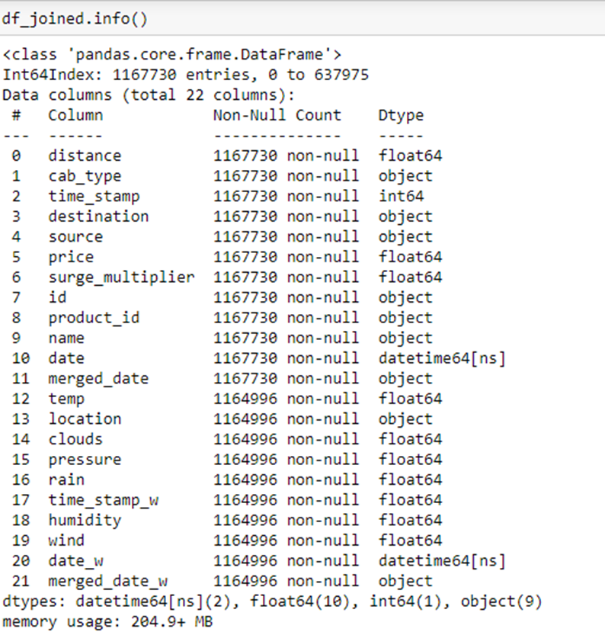

As we can see from the joined data information, the rides data expanded from 693,070 records to 1,164,996. The data has bee expanded because the data has been joined by hour information, but the weather data has record more than one for same hour. I will show below.

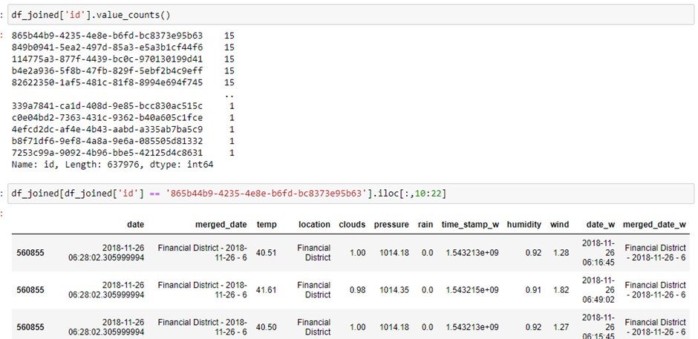

As you can see that there are 693,071 unique records. I chose the most repetitive one. All of the weather information is really similar, so I decided to make group by id.

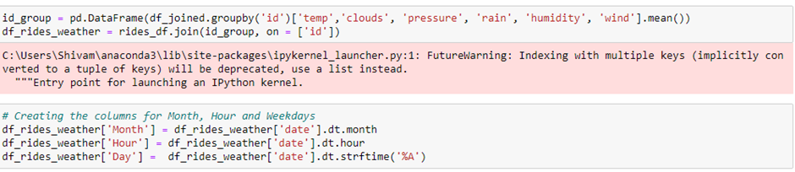

* Creating the columns for Month, Hour and Weekdays

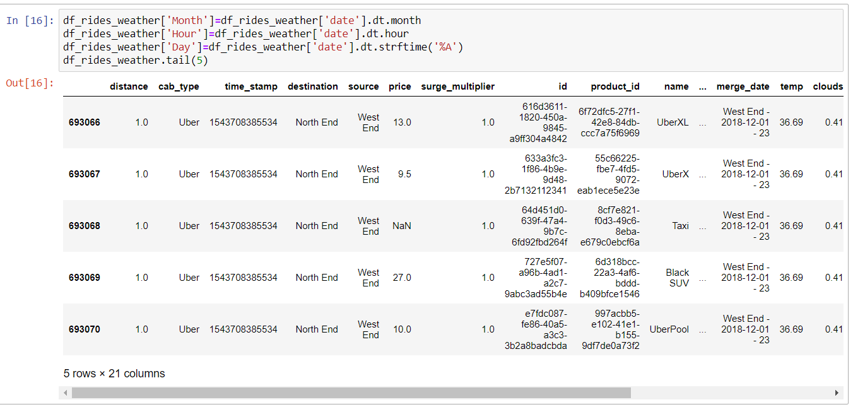

**Data Visualization**

* Data visualization is where a given data set is presented in a graphical format. It helps the detection of patterns, trends and correlations that might go undetected in text-based data.Understanding your data and the relationship present within it is just as important as any algorithm used to train your machine learning model. In fact, even the most sophisticated machine learning models will perform poorly on data that wasn’t visualized and understood properly.
* To visualize the dataset we need libraries called Matplotlib and Seaborn.
* The Matplotlib library is a Python 2D plotting library which allows you to generate plots, scatter plots, histograms, bar charts etc.
* Let’s visualize our data using Matplotlib and the Seaborn library.
* The distribution of rides in weekdays

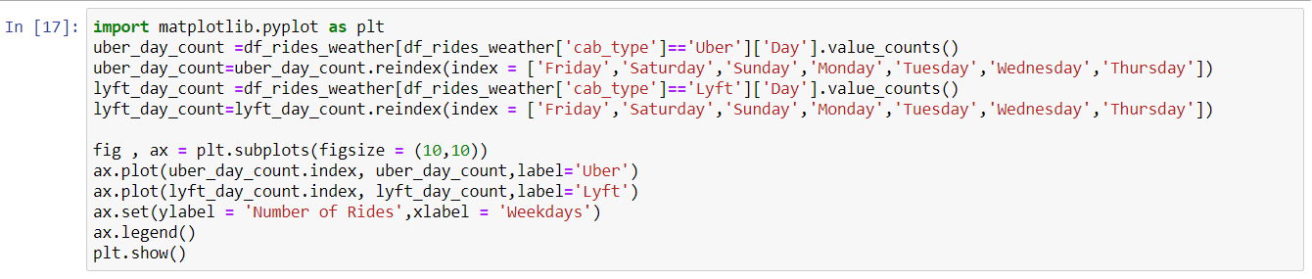

* Plot the figure 'Number of rides vs Weekdays'  (For Uber And Lyft Rides).

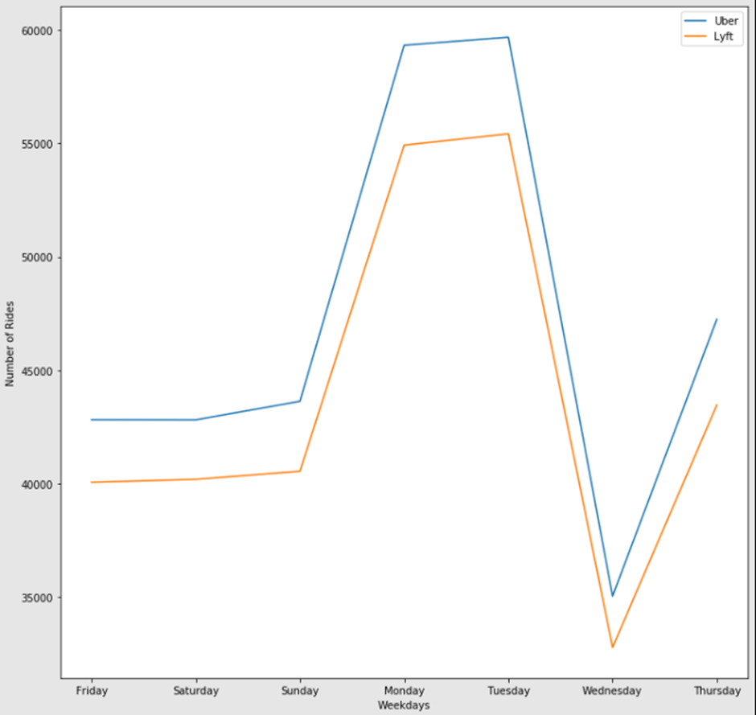

The number of rides by weekday, the ride distribution in one day

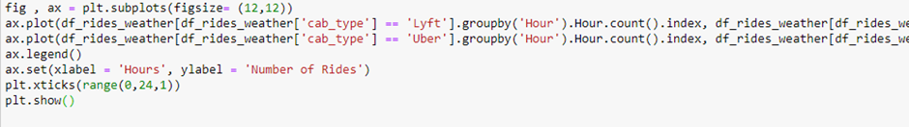

* Plot the figure 'Number of rides vs Hours (For Uber and Lyft Rides).

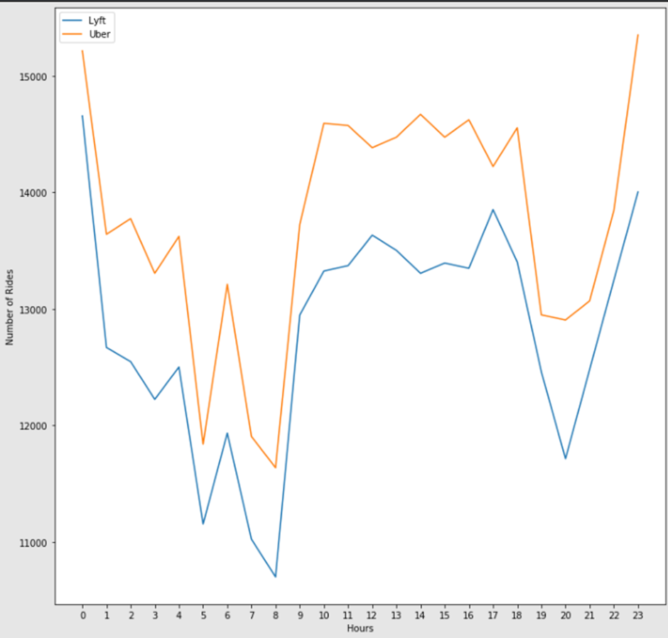

The Average price of rides by type of service and number of rides by type of service

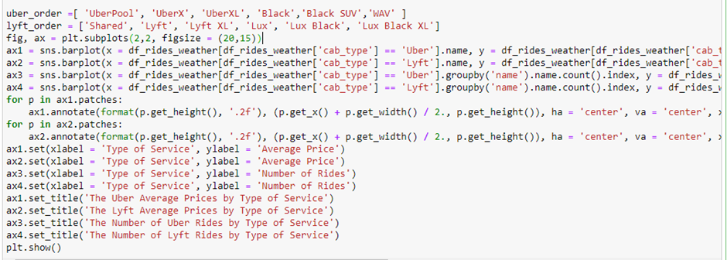

* Plot the figure for:
* The Uber Average Prices by Type of Service.
* The Lyft Average Prices by Type of Service
* The Number of Uber Rides by Type of Service
* The Number of Lyft Rides by Type of Service

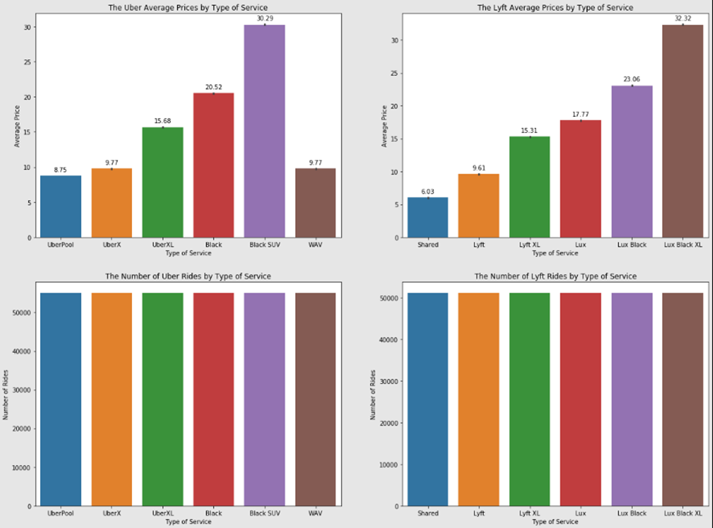

* The first two charts in the first row show the comparison of prices by type of service for UBER and LYFT Seperately.
* While UBER has extra service for the people with disabilities, LYFT hasn't this service.
* LYFT Shared prices is almost 30% lower that UberPool.
* The average price by distance

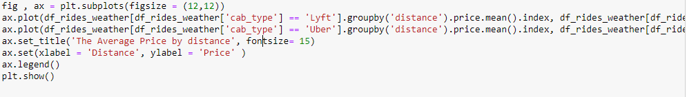

* Plot the figure 'Average price by distance (Price vs Distance for Uber And Lyft Rides).

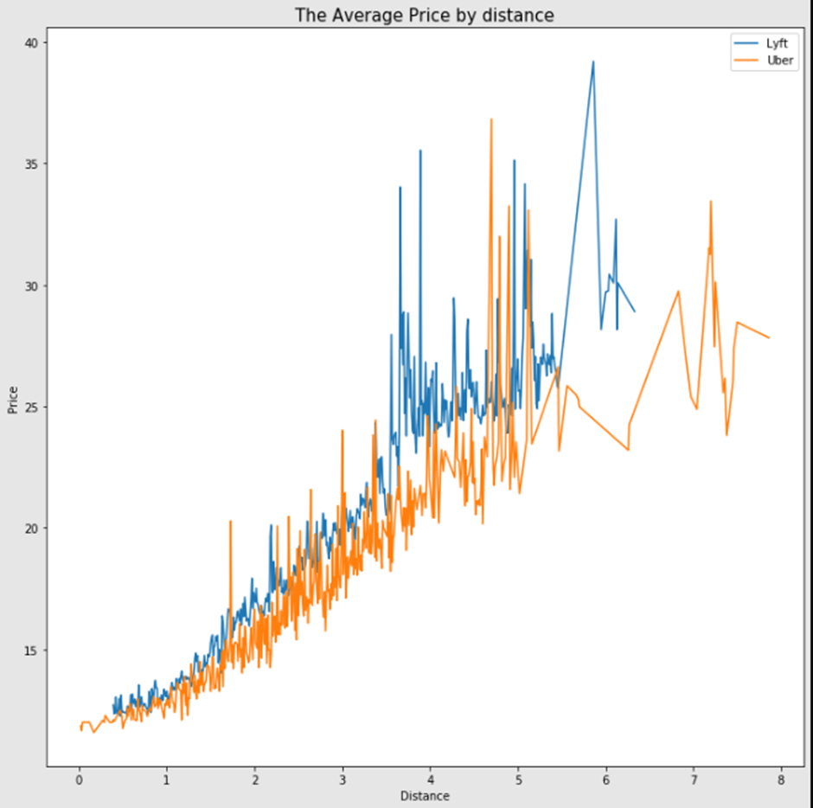

* Average LYFT prices are slightly higher than UBER prices especially for higher distances.

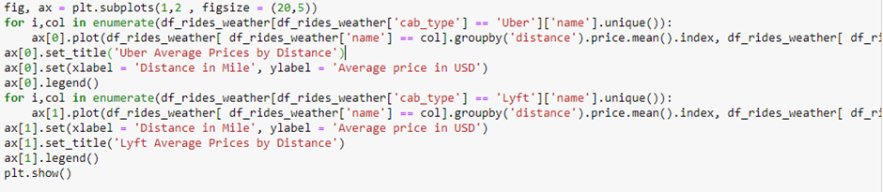

* Plot the figure Uber Average Prices by Distance & Lyft Average Prices by Distance.

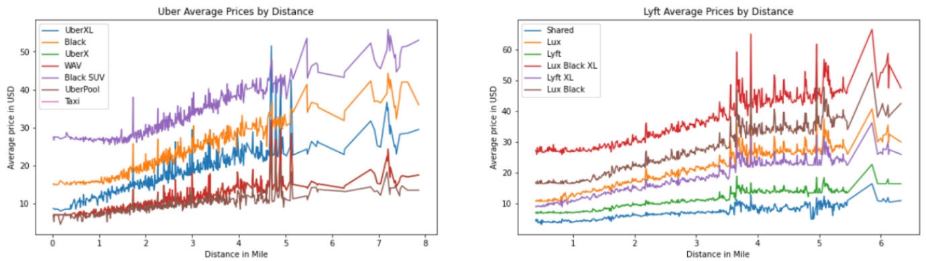

**Drop The Column from Dataframe, Merge the Dataframes**

* Remove the column merged date from rides and weather DataFrame.

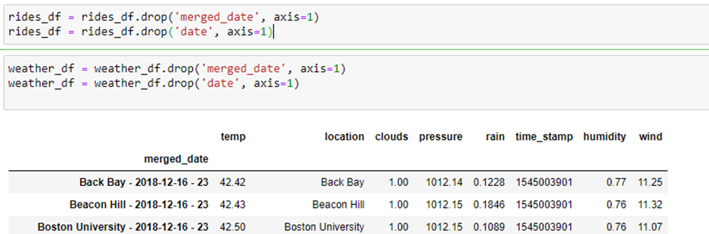

* Rename the source weather dataframe column with new name.

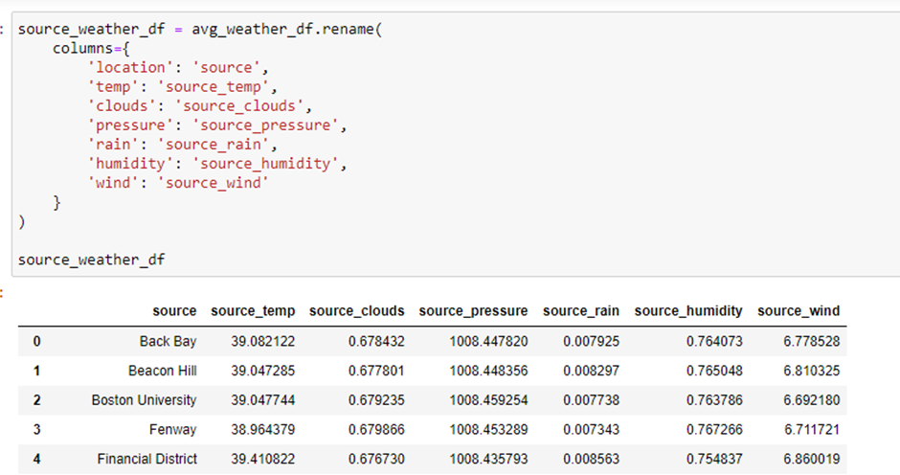

* Rename the destination weather dataframe column with new name.

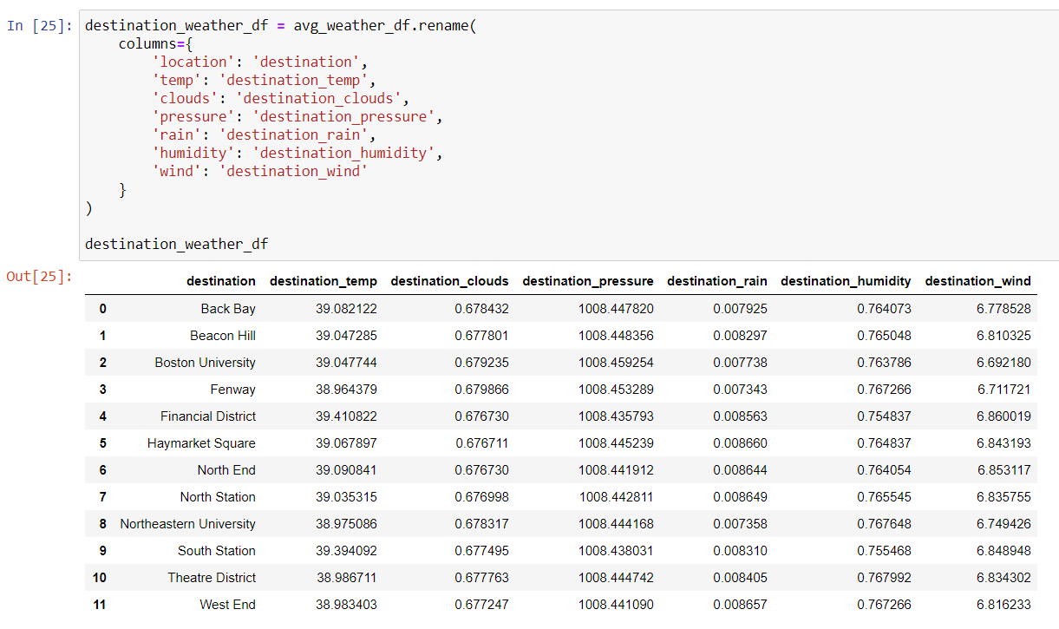

* Merge the rides data with the destination & source weather dataframe and store in data variable.

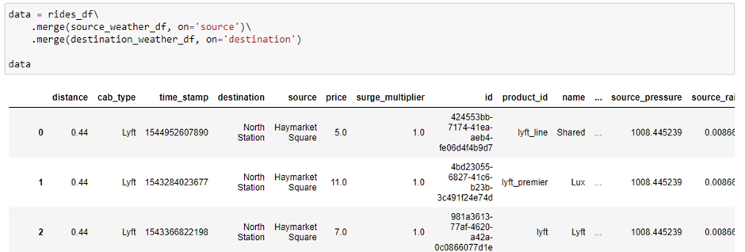

**Observing Target, Numerical and Categorical Columns**

* Categorical Columns:
* The below code is used for fetching all the object or categorical type of columns from our data and we are storing it as **set** in a variable **cat**.

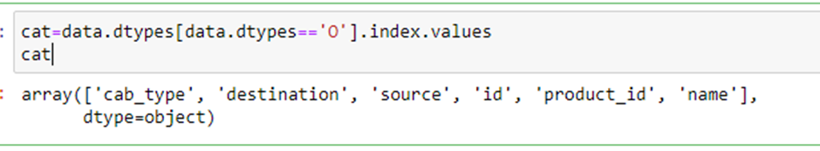

* As you can observe, it gives us the same count of columns which we found previously.

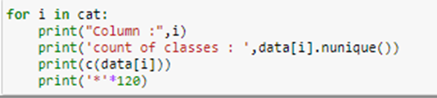

* In the above we are looping with each categorical column and printing the classes of each categorical column using the counter function so that we can detect which columns are categorical and which are not.
* If you observe some columns have a few classes and some have many, but in some columns there are similar types of classes present so let’s make that similar class into a single class using numpy.

**Numerical Columns**

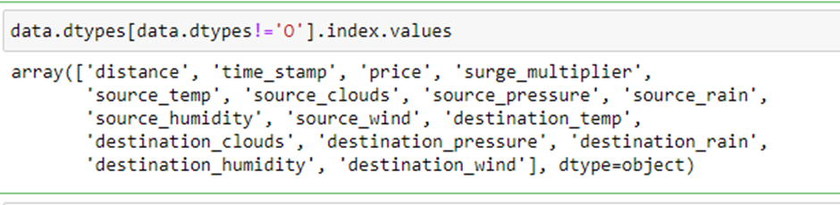

Same as we did with categorical columns, we are making use of data types for finding the continuous columns.

**Label Encoding**

* Typically, any structured dataset includes multiple columns with combinations of numerical as well as categorical variables. A machine can only understand the numbers. It cannot understand the text. That’s essentially the case with [Machine Learning algorithms](https://www.analyticsvidhya.com/blog/2017/09/common-machine-learning-algorithms/?utm_source=blog&utm_medium=one-hot-encoding-vs-label-encoding-using-scikit-learn) too.We need to convert each text category to numbers in order for the machine to process those using mathematical equations.
* How should we handle categorical variables? There are Multiple ways to handle it, but I will see one of them is Label Encoding.
* Label Encoding is a popular encoding technique for handling categorical variables. In this technique, each label is assigned a unique integer based on alphabetical ordering.
* Let’s see how to implement label encoding in Python using the [scikit-learn library](https://www.analyticsvidhya.com/blog/2020/02/everything-you-should-know-scikit-learn/?utm_source=blog&utm_medium=one-hot-encoding-vs-label-encoding-using-scikit-learn).
* As we have to convert only the text class category columns, we first select it then we will implement Label Encoding to it.

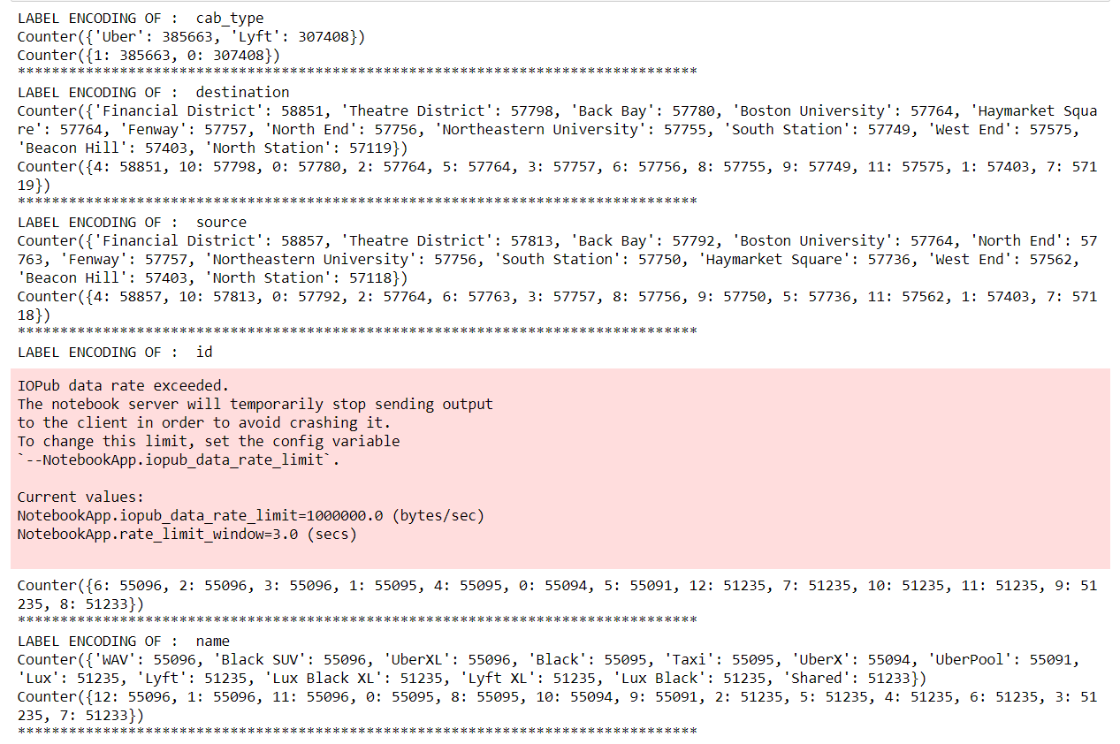

* In the above code we are looping through all the selected text class categorical columns and performing label encoding.
* If you see output of the above code, after performing label encoding alphabetical classes are converted to numeric.

**Splitting the Dataset into Dependent and Independent variables:**

* In machine learning, the concept of dependent variable (y) and independent variables(x) is important to understand. Here, Dependent variable is nothing but output in the dataset and the independent variable is all inputs in the dataset. We can denote with any symbol (alphabets). In our dataset we can say that class is the dependent variable and all other columns are independent. But in order to select the independent columns we will be selecting only those columns which are highly correlated and of some value to our dependent column.
* With this in mind, we need to split our dataset into the matrix of independent variables and the vector or dependent variable. Mathematically, Vector is defined as a matrix that has just one column.
* Let’s create out independent and dependent variables:

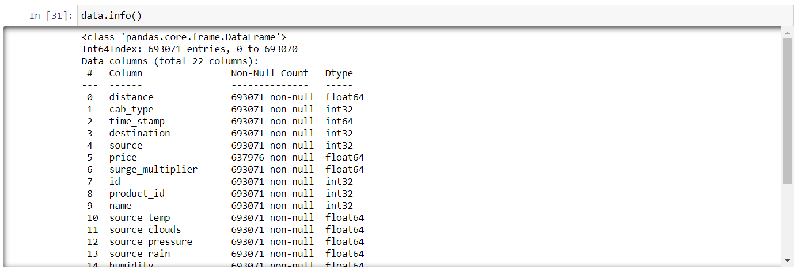

* In the above code we are creating a DataFrame of the independent variable x with our selected columns and for dependent variable y we are only taking the class column.
* Where DataFrame is used to represent a table of data with rows and columns.

### **Split The Dataset Into Train Set And Test Set**

* When you are working on a model and you want to train it, you obviously have a dataset. But after training, we have to test the model on some test dataset. For this, you will have a dataset which is different from the training set you used earlier. But it might not always be possible to have so much data during the development phase. In such cases, the solution is to split the dataset into two sets, one for training and the other for testing.
* But the question is, how do you split the data? You can’t possibly manually split the dataset into two sets. And you also have to make sure you split the data in a random manner. To help us with this task, the Scikit library provides a tool, called the Model Selection library. There is a class in the library which is,‘[train_test_split](https://scikit-learn.org/stable/modules/generated/sklearn.model_selection.train_test_split.html).’ Using this we can easily split the dataset into the training and the testing datasets in various proportions.
* The train-test split is a technique for evaluating the performance of a machine learning algorithm.
* Train Dataset: Used to fit the machine learning model.
* Test Dataset: Used to evaluate the fit machine learning model.
* In General you can allocate 80% of the dataset to training set and the remaining 20% to test set. we will create 4 sets— X_train (training part of the matrix of features), X_test (test part of the matrix of features), Y_train (training part of the dependent variables associated with the X train sets, and therefore also the same indices), Y_test (test part of the dependent variables associated with the X test sets, and therefore also the same indices.
* There are a few other parameters that we need to understand before we use the class:
* test_size — this parameter decides the size of the data that has to be split as the test dataset. This is given as a fraction. For example, if you pass 0.4 as the value, the dataset will be split 40% as the test dataset
* train_size — you have to specify this parameter only if you’re not specifying the test_size. This is the same as test_size, but instead you tell the class what percent of the dataset you want to split as the training set.
* random_state — here you pass an integer, which will act as the seed for the random number generator during the split. Or, you can also pass an instance of the Random_state class, which will become the number generator. If you don’t pass anything, the Random_state instance used by np.random will be used instead.
* Now split our dataset into a train set and test using train_test_split class from scikit learn library.

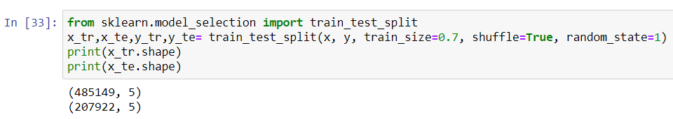

**Model Building**

**Train And Test the Model Using Random Forest Regressor**

* There are several Machine learning algorithms to be used depending on the data you are going to process such as images, sound, text, and numerical values. The algorithms that you can choose according to the objective that you might have it may be Classification algorithms are Regression algorithms.

Example: 1. Linear Regression.

2. Logistic Regression.

3. Random Forest Regression / Classification.

4. Decision Tree Regression / Classification.

* You will need to train the datasets to run smoothly and see an incremental improvement in the prediction rate.
* Now we apply the Random Forest regressor algorithm on our dataset.
* A Random Forest is an ensemble technique capable of performing both regression and classification tasks with the use of multiple decision trees and a technique called Bootstrap and Aggregation, commonly known as bagging. The basic idea behind this is to combine multiple decision trees in determining the final output rather than relying on individual decision trees.

**Build the model with the Random Forest Regressor.**

* We’re going to use x_train and y_train obtained above in train_test_split section to train our Random Forest regression model. We’re using the fit method and passing the parameters as shown below

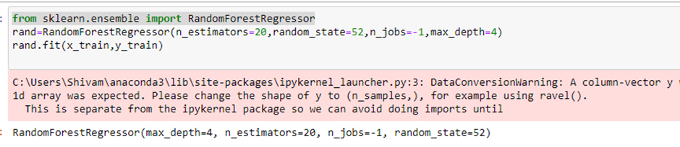

**Predict the values**

* Once the model is trained, it’s ready to make predictions. We can use the predict method on the model and pass x_test as a parameter to get the output as y_pred.
* Notice that the prediction output is an array of real numbers corresponding to the input array.

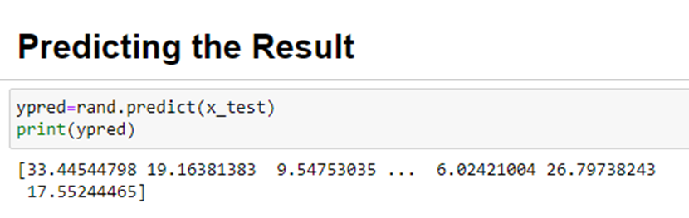

**Model Evaluation**

* Finally, we need to check to see how well our model is performing on the test data. There are many evaluation techniques. For this, we evaluate the score produced by the model.

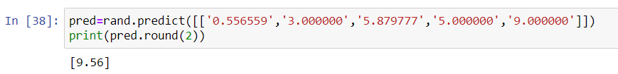

**Saving The Model**

* Pickle is used for serializing and de-serializing Python object structures, also called marshalling or flattening. Serialization refers to the process of converting an object in memory to a byte stream that can be stored on disk or sent over a network. Later on, this character stream can then be retrieved and de-serialized back to a Python object.
* Save our model by importing pickle files.

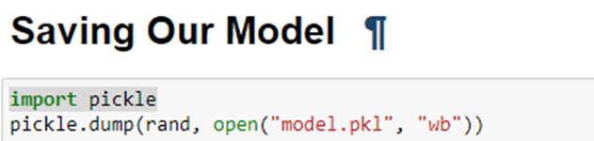

Here, rand is our random forest regressor class with saving as **model.pkl** file. Wb is the write binary in bytes.

**Build Flask Application**

**Flask Structure**

To build this flask application you should have basic knowledge of “HTML, CSS, Bootstrap, flask framework and python”

* For more information regarding [flask](https://www.tutorialspoint.com/flask/index.html)
* **Main Python Script**
* Let us build a flask file ’**lyft-uber-price-prediction.ipynb**’ which is a web framework written in python for server-side scripting. Let’s see step by step procedure for building the backend application.
* You can also run this on spyder, given as app.py
* App starts running when the “__name__” constructor is called in main.
* Render_template is used to return html files.
* “GET” method is used to take input from the user.
* “POST” method is used to display the output to the user.
* Three.html web pages are given.

### **Importing Libraries**

* Libraries required for the app to run are to be imported.

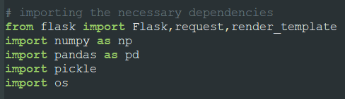

**Loading Flask and Assigning The Model Variable.**

Loading Flask and assigning the model variable

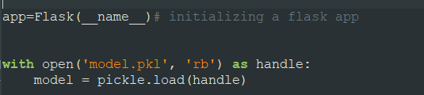

**Routing To the Html Page**

Basically, we give routes of our html pages in order to showcase the UI. By giving the routes the built code in the html page is connected to our flask app. This is how a UI can be built and showcased.

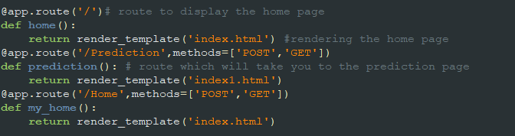

* We are routing the app to the html templates which we want to render.Firstly, we are rendering the “**index.html**” template and from there we are navigating to our index1 page for the user input and then redirect onto the result or prediction page.
* app – our flask application name
* model – it will contain the model which we build
* @app.route() – used for routing to the different pages.we have four route.
* one for routing to the home page (‘/’)
* route to the prediction page (‘/Prediction’)
* route to the same home page itself(‘/Home’)
* routing to the result page (‘/predict’)
* render_template () – it is used for render our html page from the templates folder
* predict() – is taking the values form the prediction page and storing it into a variable  and then we are creating a DataFrame along with the values and 4 independent features and finally we are predicting the values using or loaded model which we build and storing the output in a variable and returning it to the result page.
* app.run(debug=False) – for running our app

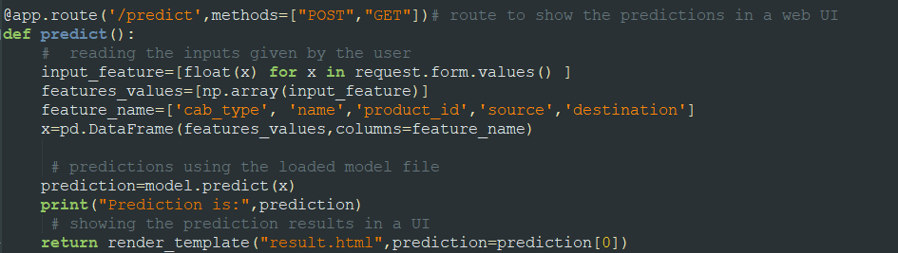

Here the route for prediction is given and necessary steps are performed in order to get the predicted output.

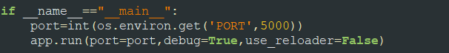

 Lastly, we run our app on the local host. Here we are running it on localhost:5000

**Run The App in Local Browser**

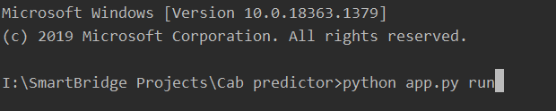

* Open anaconda prompt from the start menu
* Navigate to the folder where your python script is.
* Now type “python app.py” command
* Navigate to the localhost where you can view your web page

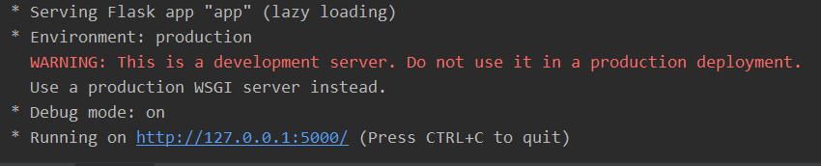

**Final UI**

Dashboard of the flask application.

* This is the main page of Dynamic price predictor for travel. Where you may know about the project and also from this page user can click onto the prediction button and they will redirect onto the prediction page for providing the inputs.

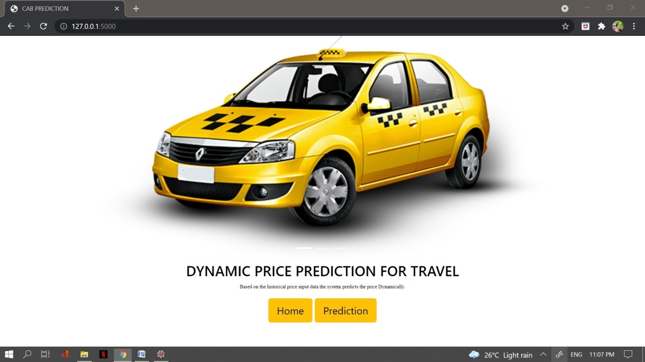

* The prediction page user gives the input for predicting the output where they can choose Cab Name, Cab Type,Cab Service Type,Source & Destination then click to predict the output.

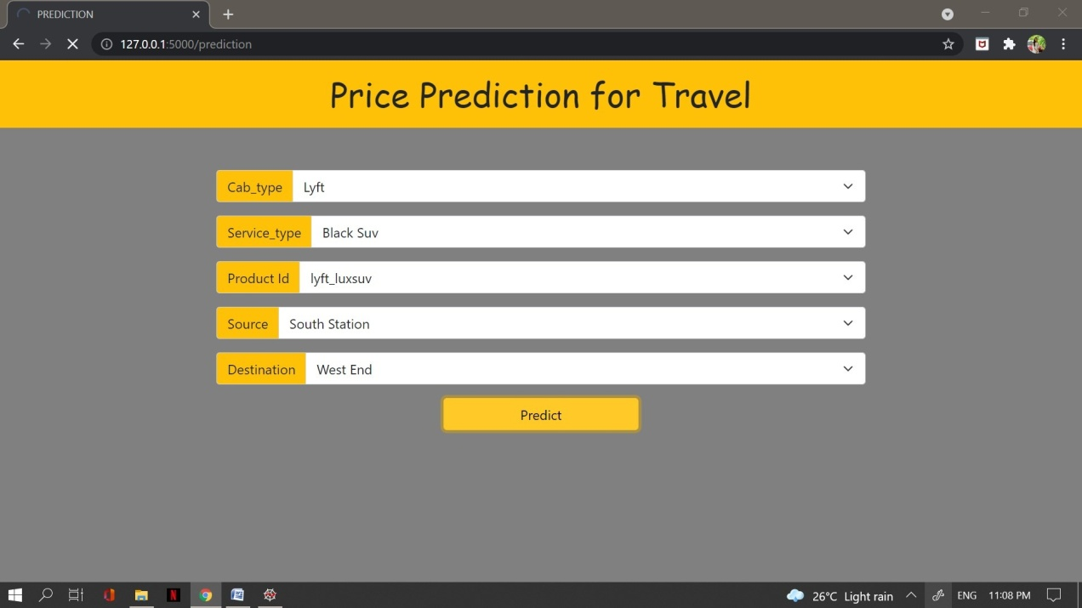

* In the predict page user will get the output based on the inputs they given in the prediction page.

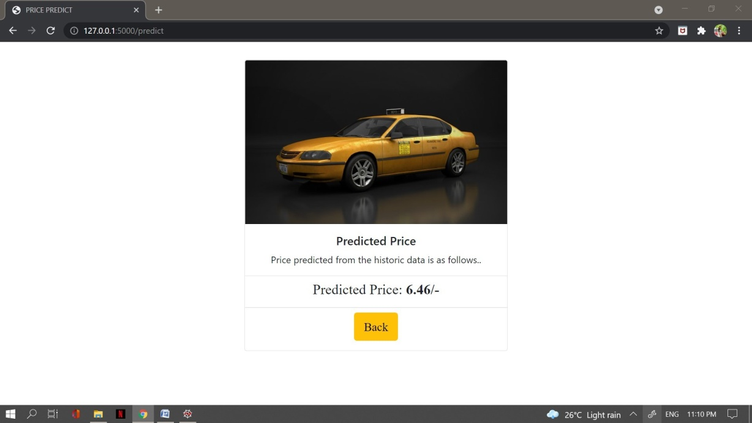

**Train The Model On IBM**

In this milestone, you will learn how to build a Machine Learning Model and deploy it on the IBM Cloud.

**Register For IBM Cloud**

**IBM Account:**

* Please click [here](https://cloud.ibm.com/registration)to register for IBM
* Please click [here](https://cloud.ibm.com/login)to log in to IBM Account

Watch the below video to register and login into your IBM account

Link:<https://youtu.be/4y_zD-0Q3F8>

**Train The ML Model On IBM**

watch below video to train the Machine learning model on IBM Watson

Link:<https://youtu.be/TysuP3KgSzc>

Watch the below video to integrate the scoring endpoint to the flask

Link:https://youtu.be/ST1ZYLmYw2U